Parte 3

|  |
| --- |
|  |

1 What are you cocking?

1. Yes, I am
2. I am cocking a cake
3. What are you doing?



2 Are you sick?

1. How?
2. No, I am not sick
3. I want a pizza

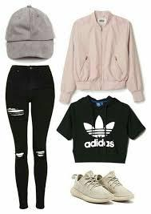

3 We sell a awesome clothes

1. Where?
2. She is my mom
3. Are you ready

|  |
| --- |
|  |

4 Is he the brother of samantha?

1. Yes, she is
2. No, he is not
3. Samantha is a beautiful person

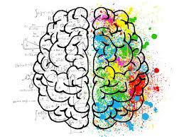

5 María is the most intelligent person of the school

1. Who?
2. My mom is a awesome person
3. Yes, she is the most intelligent person